EIGRP Configuration With Packet Tracer
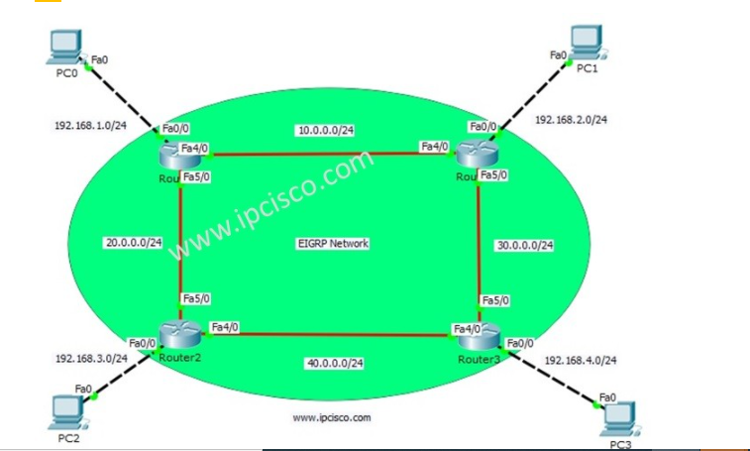

PC0: 192.168.1.1 255.255.255.0 GW:192.168.1.2
PC1: 192.168.2.1 255.255.255.0 GW:192.168.2.2
PC2: 192.168.3.1 255.255.255.0 GW:192.168.3.2
PC3: 192.168.4.1 255.255.255.0 GW:192.168.4.2

We will start our EIGRP Packet Tracer Configuration with Router 0 and we will continue with Router1, Router2 and Router3 orderly. Let’s start!
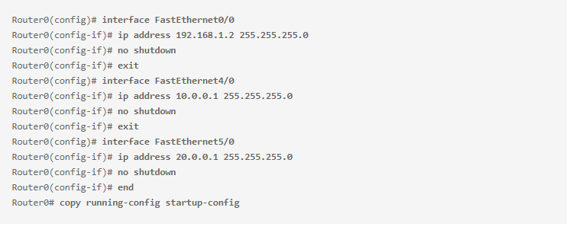
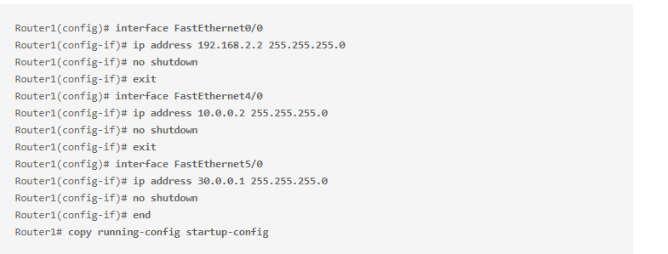
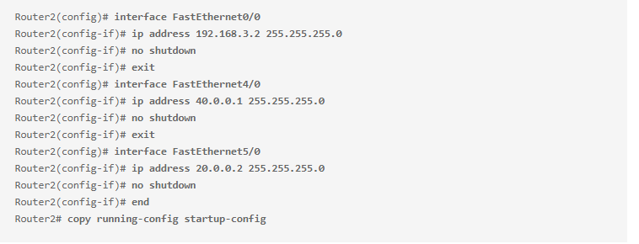
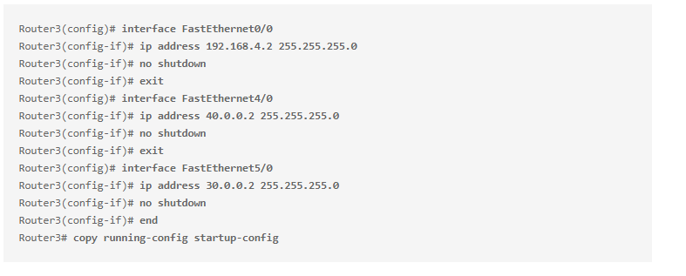

EIGRP Configuration on Routers

For EIGRP Configuration, we will use Autonomous System Number. We will use this number with “router eigrp” command. After this command, we will be under router configuration mode. We will add networks that run EIGRP one by one. Lastly we will add “no auto-summary” command to avoid automatic summarization on routing table.

Firstly, let’s start our EIGRP Config with Router0 and then configure EIGRP on the other Routers.
Here, our EIGRP Autonomous number will be 100. And for Router0, 192.168.1.0, 10.0.0.0, 20.0.0.0 network will be added under this EIGRP process. These are the directly connected networks to Router0.
Router0(config)# router eigrp 100
Router0(config-router)# network 192.168.1.0
Router0(config-router)# network 10.0.0.0
Router0(config-router)# network 20.0.0.0
Router0(config-router)# no auto-summary
Router0(config-router)# end
Router0# copy running-config startup-config
The similar configuration will be done on Router1 also. Here, only the networks will be changed. The direclty connected networks to Router1 will be added.
Router1(config)# router eigrp 100
Router1(config-router)# network 192.168.2.0
Router1(config-router)# network 10.0.0.0
Router1(config-router)# network 30.0.0.0
Router1(config-router)# no auto-summary
Router1(config-router)# end
Router1# copy running-config startup-config
For Router2 and Router3 the similar Cisco EIGRP Configuration will be done. Only ne added networks will be changed. Because each router has different directly connected networks.
Router2(config)# router eigrp 100
Router2(config-router)# network 192.168.3.0
Router2(config-router)# network 20.0.0.0
Router2(config-router)# network 40.0.0.0
Router2(config-router)# no auto-summary
Router2(config-router)# end
Router2# copy running-config startup-config

Router3(config)# router eigrp 100
Router3(config-router)# network 192.168.4.0
Router3(config-router)# network 30.0.0.0
Router3(config-router)# network 40.0.0.0
Router3(config-router)# no auto-summary
Router3(config-router)# end
Router3# copy running-config startup-config

Configuration Verification

After our Packet Tracer Configuartion, now let’s verify our EIGRP Configuration with EIGRP Show Commands. Here, we will check this only on some routers, not on all of them. So what are these verification commands? Some of thes eEIGRP verification commands are given below:
- show ip eigrp
- show ip eigrp neighbors
- show ip eigrp interfaces
- show ip eigrp topology
- show ip route eigrp
- show ip protocols

Now, let’s chekc each of these commands on Cisco routers.
When we use “show ip eigrp ?” command, we can see our eigrp options that we can use on Packet Tracer.
Router# show ip eigrp ? interfaces IP-EIGRP interfaces neighbors IP-EIGRP neighbors topology IP-EIGRP Topology Table traffic IP-EIGRP Traffic Statistics
Here, firstly we will check EIGRP neighbours of Router0 and Router1. We will see this neighbors with “show ip eigrp neighbors” command.
Router0# show ip eigrp neighbors
IP-EIGRP neighbors for process 100
H Address Interface Hold Uptime SRTT RTO Q Seq
(sec) (ms) Cnt Num
0 10.0.0.2 Fa4/0 14 00:14:53 40 1000 0 12
1 20.0.0.2 Fa5/0 12 00:14:53 40 1000 0 11
We can verify the EIGRP interfaces with “show ip eigrp interfaces” command.

Router0# show ip eigrp interfaces
IP-EIGRP interfaces for process 100

Xmit Queue Mean Pacing Time Multicast Pending
Interface Peers Un/Reliable SRTT Un/Reliable Flow Timer Routes
Fa4/0 1 0/0 1236 0/10 0 0
Fa5/0 1 0/0 1236 0/10 0 0
Fa0/0 0 0/0 1236 0/10 0 0

Router1# show ip eigrp interfaces
IP-EIGRP interfaces for process 100

Xmit Queue Mean Pacing Time Multicast Pending
Interface Peers Un/Reliable SRTT Un/Reliable Flow Timer Routes
Fa4/0 1 0/0 1236 0/10 0 0
Fa5/0 1 0/0 1236 0/10 0 0
Fa0/0 0 0/0 1236 0/10 0 0

We can see the whole Topology Table of Router0 and Router1 with show ip eigrp topology command.

Router0# show ip eigrp topology
IP-EIGRP Topology Table for AS 100/ID(192.168.1.2)

Codes: P - Passive, A - Active, U - Update, Q - Query, R - Reply,
r - Reply status

P 10.0.0.0/24, 1 successors, FD is 28160
via Connected, FastEthernet4/0
P 20.0.0.0/24, 1 successors, FD is 28160
via Connected, FastEthernet5/0
P 30.0.0.0/24, 1 successors, FD is 30720
via 10.0.0.2 (30720/28160), FastEthernet4/0
P 40.0.0.0/8, 1 successors, FD is 30720
via 20.0.0.2 (30720/28160), FastEthernet5/0
P 192.168.1.0/24, 1 successors, FD is 28160
via Connected, FastEthernet0/0
P 192.168.2.0/24, 1 successors, FD is 30720
via 10.0.0.2 (30720/28160), FastEthernet4/0
P 192.168.3.0/24, 1 successors, FD is 30720
via 20.0.0.2 (30720/28160), FastEthernet5/0
P 192.168.4.0/24, 1 successors, FD is 33280
via 10.0.0.2 (33280/30720), FastEthernet4/0

Router1# show ip eigrp topology
IP-EIGRP Topology Table for AS 100/ID(192.168.2.2)

Codes: P - Passive, A - Active, U - Update, Q - Query, R - Reply,
r - Reply status

P 10.0.0.0/24, 1 successors, FD is 28160
via Connected, FastEthernet4/0
P 20.0.0.0/24, 1 successors, FD is 30720
via 10.0.0.1 (30720/28160), FastEthernet4/0
P 30.0.0.0/24, 1 successors, FD is 28160
via Connected, FastEthernet5/0
P 40.0.0.0/8, 1 successors, FD is 30720
via 30.0.0.2 (30720/28160), FastEthernet5/0
P 192.168.1.0/24, 1 successors, FD is 30720
via 10.0.0.1 (30720/28160), FastEthernet4/0
P 192.168.2.0/24, 1 successors, FD is 28160
via Connected, FastEthernet0/0
P 192.168.3.0/24, 1 successors, FD is 33280
via 10.0.0.1 (33280/30720), FastEthernet4/0
P 192.168.4.0/24, 1 successors, FD is 30720
via 30.0.0.2 (30720/28160), FastEthernet5/0

We can also see the EIGRP traffic statistics with “show ip eigrp traffic” command.

